Brandon Wade

CPE301 – SPRING 2016

Design Assignment 5

**DO NOT REMOVE THIS PAGE DURING SUBMISSION:**

The student understands that all required components should be submitted in complete for grading of this assignment.

|  |  |  |  |
| --- | --- | --- | --- |
| **NO** | **SUBMISSION ITEM** | **COMPLETED (Y/N)** | **MARKS**  **(/MAX)** |
| 0. | COMPONENTS LIST AND CONNECTION BLOCK DIAGRAM w/ PINS |  |  |
| 1. | INITIAL CODE OF TASK 1/A |  |  |
| 2. | INCREMENTAL / DIFFERENTIAL CODE OF TASK 2/B |  |  |
| 3. | INCREMENTAL / DIFFERENTIAL CODE OF TASK 3/C |  |  |
| 4. | INCREMENTAL / DIFFERENTIAL CODE OF TASK 4/D |  |  |
| 5. | INCREMENTAL / DIFFERENTIAL CODE OF TASK 5/E |  |  |
| 6. | SCHEMATICS |  |  |
| 7. | SCREENSHOTS OF EACH TASK OUTPUT |  |  |
| 8. | SCREENSHOT OF EACH DEMO |  |  |
| 9. | VIDEO LINKS OF EACH DEMO |  |  |
| 10. | GOOGLECODE LINK OF THE DA |  |  |
|  |  |  |  |
|  |  |  |  |

|  |  |  |  |
| --- | --- | --- | --- |
| 0. | COMPONENTS LIST AND CONNECTION BLOCK DIAGRAM w/ PINS |  |  |

Atmel Studio 7.0

ATMega328P Chip

Breadboard

LM35 Temperature Sensor

LCD Module

LM35

LCD Module

D0

D1

D2

D3

D4

D5

D6

D7

RS

RW

E

ATMega328P

PD0

PD1

PD2

PD3

PD4

PD5

PD6

PD7

PB0

PB1

PB2

PC0

|  |  |  |  |
| --- | --- | --- | --- |
| 1. | INITIAL CODE OF TASK 1/A |  |  |

// Brandon Wade

#define *F_CPU* 8000000UL

#include <avr/io.h> //standard AVR header

#include <util/delay.h> //delay header

#include <avr/interrupt.h>

#define LCD_DPRT PORTD //LCD DATA PORT

#define LCD_DDDR DDRD //LCD DATA DDR

#define LCD_DPIN PIND //LCD DATA PIN

#define LCD_CPRT PORTB //LCD COMMANDS PORT

#define LCD_CDDR DDRB //LCD COMMANDS DDR

#define LCD_CPIN PINB //LCD COMMANDS PIN

#define LCD_RS 0 //LCD RS

#define LCD_RW 1 //LCD RW

#define LCD_EN 2 //LCD EN

volatile *uint8_t* ADCvalue; // Global variable, set to volatile if used withIS

void lcdCommanda (unsigned char cmnd)

{

LCD_DPRT = cmnd; //send cmnd to data port

LCD_CPRT &= ~(1<<LCD_RS); //RS = 0 for command

LCD_CPRT &= ~(1<<LCD_RW); //RW = 0 for write

LCD_CPRT |= (1<<LCD_EN); //EN = 1 for H-to-L pulse

*_delay_us*(1); //wait to make enable wide

LCD_CPRT &= ~(1<<LCD_EN); //EN = 0 for H-to_L pulse

*_delay_us*(100); //wait to make enable wide

}

void lcdData(unsigned char data)

{

LCD_DPRT = data; //send data to data port

LCD_CPRT |= (1<<LCD_RS); //RS = 1 for data

LCD_CPRT &= ~(1<<LCD_RW); //RW = 0 for write

LCD_CPRT |= (1<<LCD_EN); //EN = 1 for H-to-L pulse

*_delay_us*(1); //wait to make enable wide

LCD_CPRT &= ~(1<<LCD_EN); //EN = 0 for H-to_L pulse

*_delay_us*(100); //wait to make enable wide

}

void lcd_init()

{

LCD_DDDR = 0xFF;

LCD_CDDR = 0xFF;

LCD_CPRT &=~(1<<LCD_EN); //LCD_EN = 0

*_delay_us*(2000); //wait for init

lcdCommanda(0x38); //inti. LCD 2 line, 5x7

lcdCommanda(0x0E); //display on, cursor on

lcdCommanda(0x01); //clear LCD

*_delay_us*(2000); //wait

lcdCommanda(0x06); //shift cursor right

}

void lcd_gotoxy(unsigned char x, unsigned char y)

{

unsigned char firstCharAdr[] = {0x80, 0xC0};

lcdCommanda(firstCharAdr[y-1] + x -1);

*_delay_us*(100);

}

void lcd_print(char * str)

{

unsigned char i = 0;

while (str[i]!=0)

{

lcdData(str[i]);

i++;

}

}

void adc_init (void)

{

ADMUX = 0; // use ADC0

ADMUX |= (1 << REFS0) | (1 <<REFS1); // use AVcc as the reference

ADMUX |= (1 << ADLAR); // Right adjust for 8 bit resolution

ADCSRA |= (1 << ADPS2) | (1 << ADPS1) | (0 << ADPS0); // 64 prescale for 8Mhz

ADCSRA |= (1 << ADATE); // Set ADC Auto Trigger Enable

ADCSRB = 0; // 0 for free running mode

ADCSRA |= (1 << ADEN); // Enable the ADC

ADCSRA |= (1 << ADIE); // Enable Interrupts

ADCSRA |= (1 << ADSC); // Start the ADC conversion

}

ISR(ADC_vect)

{

ADCvalue = ADCH; // only need to -read the high value for 8 bit

}

int main(void)

{

float temp; // used to get temperate as float

char* s = " . F"; // string to be printed

adc_init (); // initialize adc

sei(); // enable interrupts

lcd_init(); // initialize lcd

while(1)

{

temp = ADCvalue * (1.1 / 1024) / .01; // adc conversion

temp = temp * 1.8 + 32; // convert from C to F

s[1] = temp / 10 + '0'; // tens place

s[2] = (int)temp % 10 + '0'; // ones place

s[4] = (int)(temp * 10) % 10 + '0'; // tenths place

lcd_gotoxy(1,1); // set cursor position to beginning

lcd_print("Temp is:"); // print label

lcd_gotoxy(1,2); // set cursor to middle of lcd

lcd_print(s); // print string

*_delay_ms*(500); // update every half second

}

return 0;

}

|  |  |  |  |
| --- | --- | --- | --- |
| 6. | SCHEMATICS |  |  |

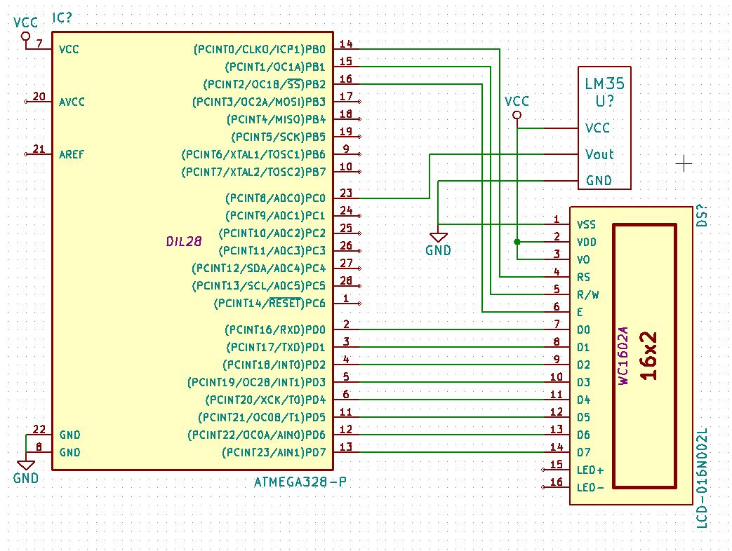

Schematic of ATMega328P, LCD, and Temperature Sensor

|  |  |  |  |
| --- | --- | --- | --- |
| 7. | SCREENSHOTS OF EACH TASK OUTPUT |  |  |

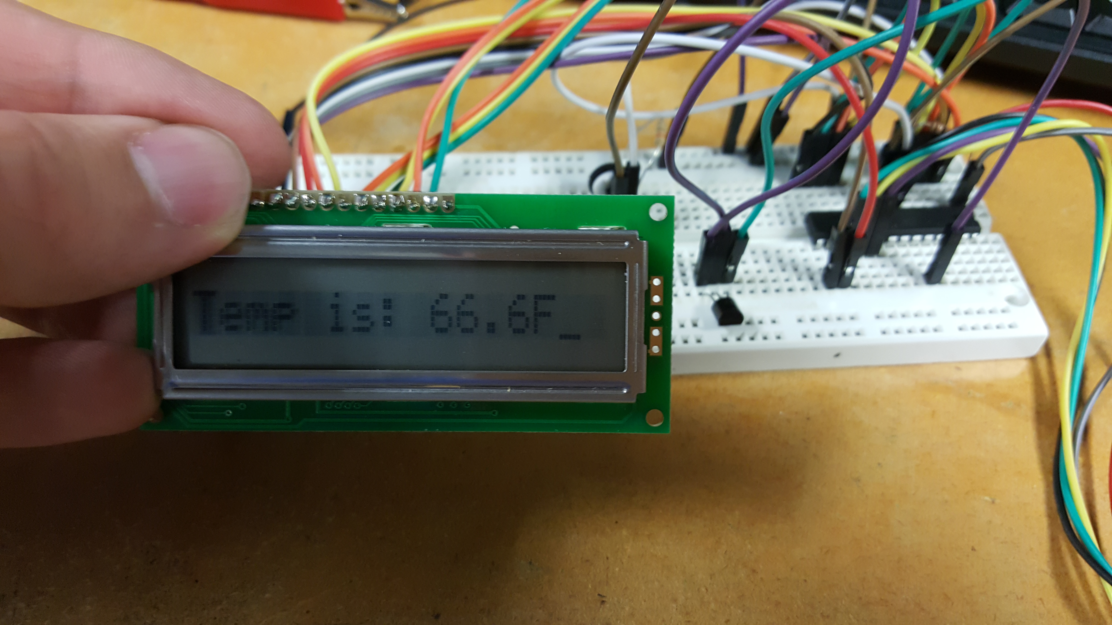

|  |  |  |  |
| --- | --- | --- | --- |
| 8. | SCREENSHOT OF EACH DEMO |  |  |

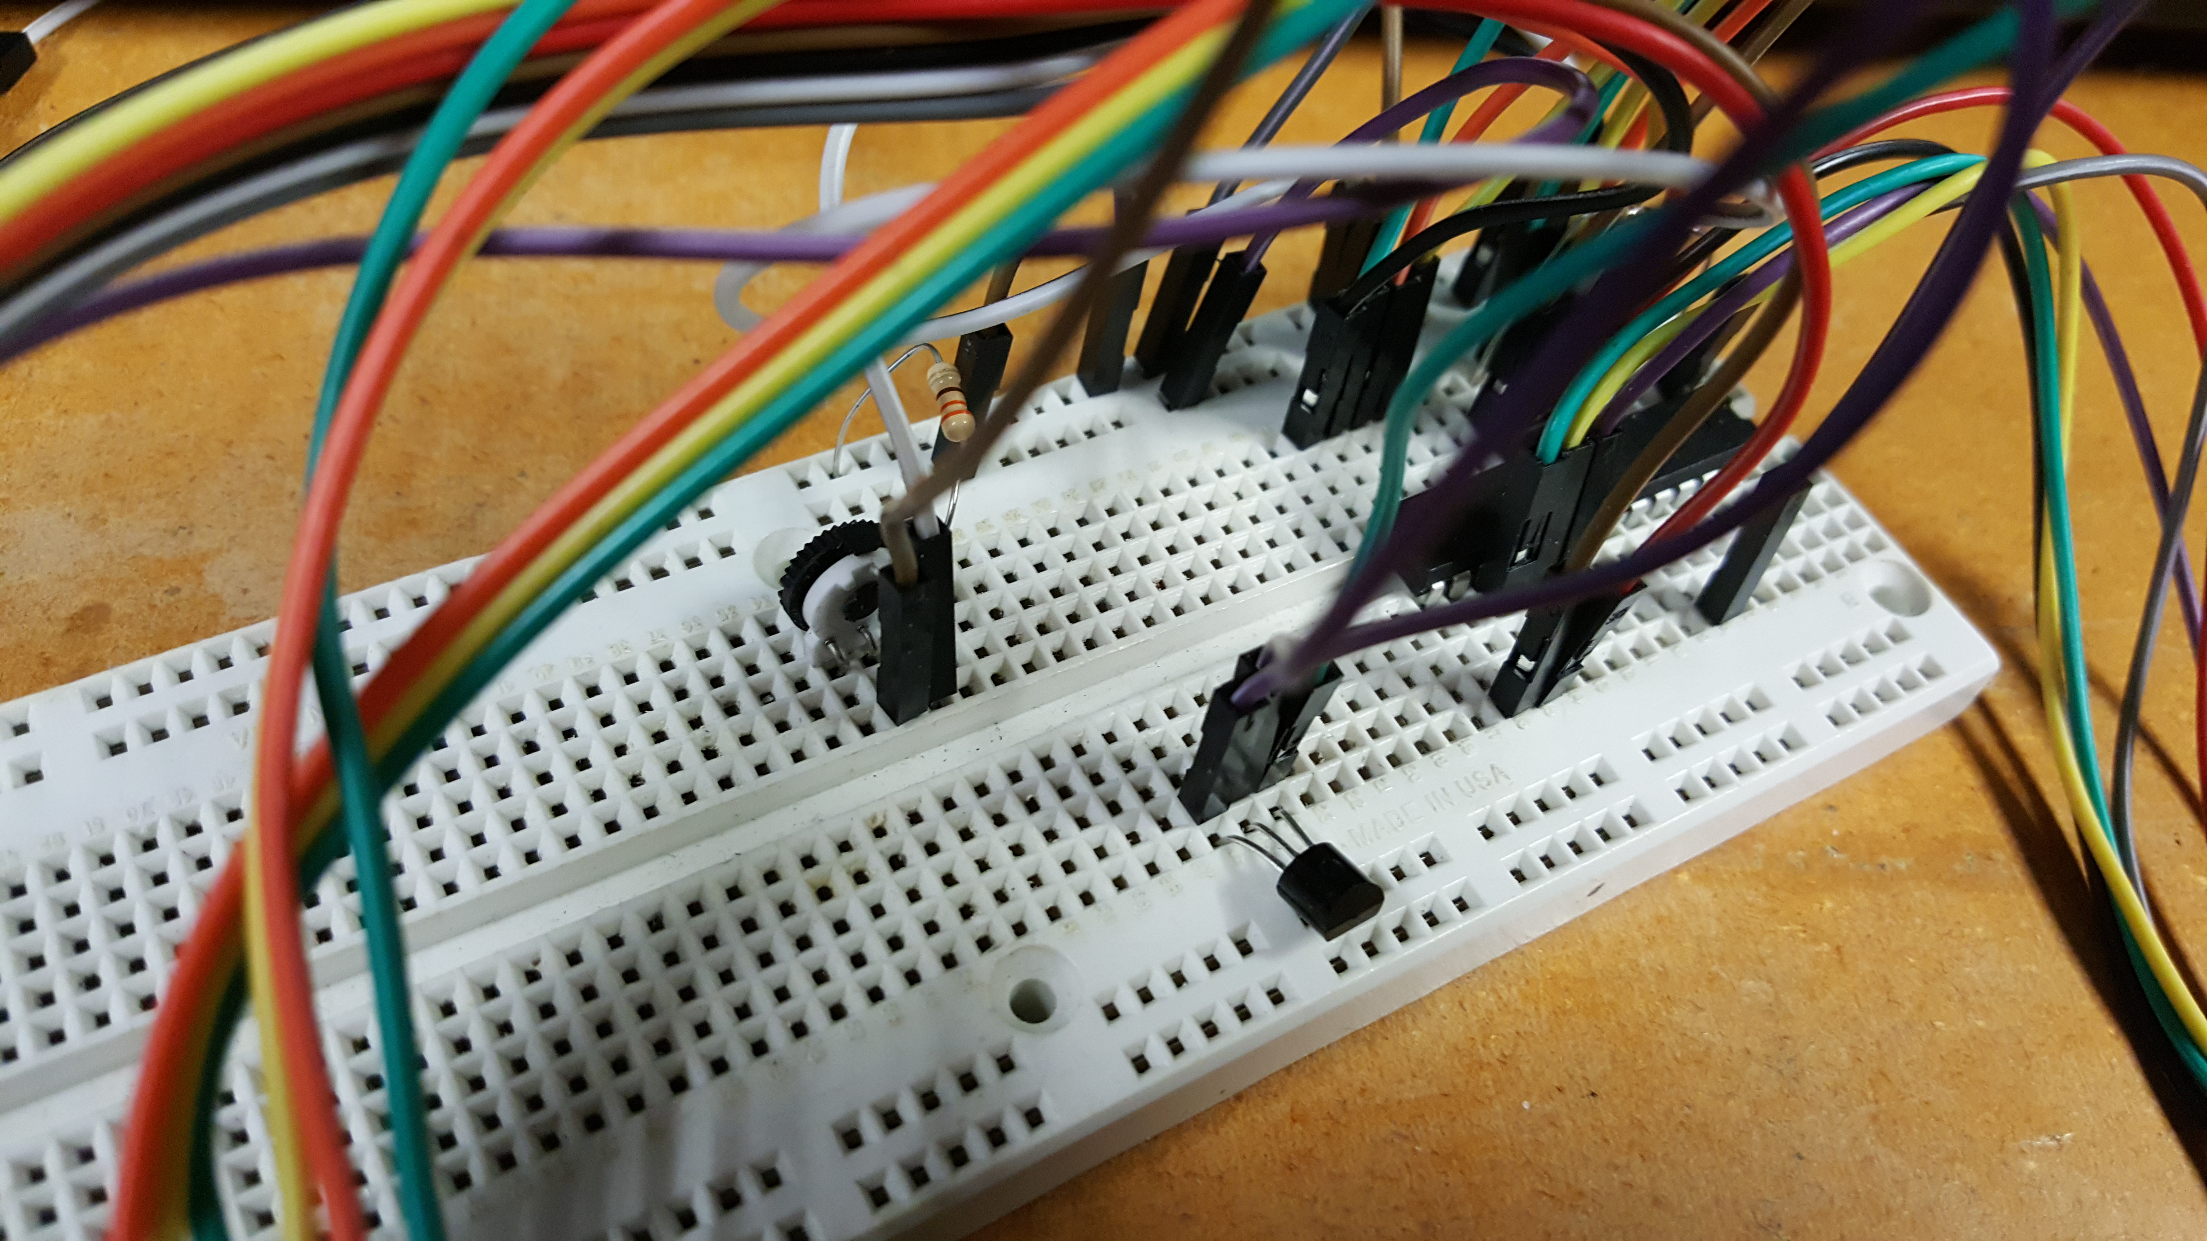

Temperature sensor located toward the bottom middle of picture, orange/yellow/green wires going off screen connect to LCD module (seen in previous picture)

|  |  |  |  |
| --- | --- | --- | --- |
| 9. | VIDEO LINKS OF EACH DEMO |  |  |
| Task1 - <https://www.youtube.com/watch?v=CBYVZrYqv2k> | | | |
| 10. | GOOGLECODE LINK OF THE DA |  |  |
| <https://github.com/wadeb1/KF3HF6ZFMP.git> | | | |

**Student Academic Misconduct Policy**

<http://studentconduct.unlv.edu/misconduct/policy.html>

“This assignment submission is my own, original work”.

Brandon Wade